**Semester One**

**Examination 2023**

**Question/Answer booklet**

**PHYSICS**

**UNIT 3**

Name: _______________________________________________________

Teacher: ___________________________________________________

***TIME ALLOWED FOR THIS PAPER***

Reading time before commencing work: Ten minutes

Working time for the paper: Three hours

***MATERIALS REQUIRED/RECOMMENDED FOR THIS PAPER***

**To be provided by the supervisor:**

* This Question/Answer Booklet; Formula and Constants sheet

**To be provided by the candidate:**

* Standard items: pens, pencils, eraser or correction fluid, ruler, highlighter.
* Special items: Calculators satisfying the conditions set by the SCSA for this subject.

***IMPORTANT NOTE TO CANDIDATES***

No other items may be taken into the examination room. It is **your** responsibility to ensure that you do not have any unauthorised notes or other items of a non-personal nature in the examination room. If you have any unauthorised material with you, hand it to the supervisor **before** reading any further.

**Structure of this paper**

|  |  |  |  |  |  |
| --- | --- | --- | --- | --- | --- |
| Section | Number of questions available | Number of questions to be answered | Suggested working time  (minutes) | Marks available | Percentage of exam |
| Section One:  Short Response | 11 | 11 | 50 | 54 | 30 |
| Section Two:  Problem Solving | 7 | 7 | 90 | 90 | 50 |
| Section Three:  Comprehension | 2 | 2 | 40 | 36 | 20 |
|  |  |  | **Total** | 180 | 100 |

**Instructions to candidates**

1. The rules for the conduct of Western Australian external examinations are detailed in the *Year 12 Information Handbook 2023.* Sitting this examination implies that you agree to abide by these rules.
2. Write your answers in this Question/Answer Booklet.
3. When calculating numerical answers, show your working or reasoning clearly. Give final answers to **three (3)** significant figures and include appropriate units where applicable.

When estimating numerical answers, show your working or reasoning clearly. Give final answers to a maximum of **two (2)** significant figures and include appropriate units where applicable.

1. You must be careful to confine your responses to the specific questions asked and follow any instructions that are specific to a particular question.
2. Spare pages are included at the end of this booklet. They can be used for planning your responses and/or as additional space if required to continue an answer.
   * Planning: If you use the spare pages for planning, indicate this clearly.
   * Continuing an answer: If you need to use the space to continue an answer, indicate in the original answer space where the answer is continued, i.e. give the page number. Refer to the question(s) where you are continuing your work.

**Section One: Short Response 30% (54 Marks)**

This section has **eleven (11)** questions. Answer **all** questions. Write your answers in the space provided.

When calculating numerical answers, show your working and reasoning clearly. Give final answers to **three (3)** significant figures and include appropriate units where applicable.

When estimating numerical answers, show your working and reasoning clearly. Give final answers to a maximum of **two (2)** significant figures and include appropriate units where applicable.

Supplementary pages for planning/continuing your answers to questions are provided at the end of the Question/Answer booklet. If you use these pages to continue an answer, indicate at the original answer where the answer is continued, i.e. – give the page number.

Suggested working time for this section is 50 minutes.

**Question 1 (4 marks)**

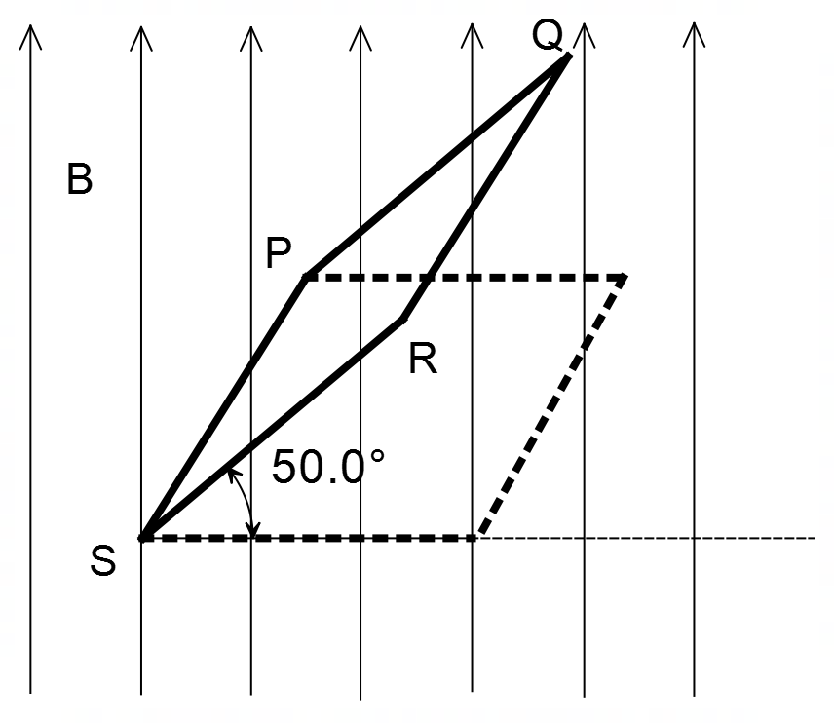A square loop of wire PQRS of side length 0.750 m is held at an angle of 50.0° to the horizontal in a vertical magnetic field of strength 1.26 T as shown.

If the loop PQRS is rotated about side PS to the horizontal position in a time of 0.430 seconds, as shown, calculate the magnitude of the average EMF generated within the coil.

Answer ________________ V

**Question 2 (6 marks)**

A 2.00 m long uniform plank, of mass 1.60 kg, rests midway on top of a 0.500 m wide post, as shown below. Cat A and Cat B, starting at positions A and B respectively, move at equal speeds towards opposite ends of the plank. Cat A has a mass of 1.50 kg and Cat B has a mass of 4.00 kg.

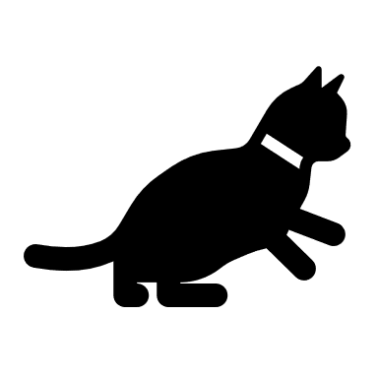



Calculate the maximum distance between Cat A and Cat B, before the plank becomes unstable.

Answer ________________ m

**Question 3 (5 marks)**

A small 4.50 g aluminium ball is statically charged with –7.00 µC. The aluminium ball is suspended motionless in an external uniform vertical electric field.

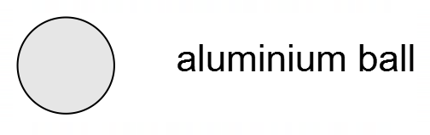

(a) On the diagram above draw the external electric field, indicating at least 4 field lines.

(2 marks)

(b) Calculate the strength of the vertical electric field. (3 marks)

Answer _________________ N C–1

**Question 4 (7 marks)**

A skateboarder travelling at a constant velocity of 4.40 m s-1 along a flat path encounters a downhill gradient 37⁰ below the horizontal. This gradient stretches a distance of 56.5 m. The skateboarder rides the skateboard down the hill without attempting to alter their speed, preferring to allow gravity to do the work.



37⁰

56.5 m

(a) Determine the downhill acceleration of the skateboarder. State any assumptions you had to make in your calculation. (2 marks)

(b) Calculate the time for the skateboarder to reach the bottom of the hill (if you couldn’t get an

answer to part (a), use a = 6.00 m s-2). (4 marks)

(c) Given that the actual time taken for the skateboarder to reach the bottom of the hill was

4.23 s, comment on the validity of your assumption in part (a). (1 mark)

**Question 5 (4 marks)**

A painter is cleaning a paint roller and is using the water hose to do so. The painter notices that as the 8.00 cm diameter roller is sprayed with water the roller spins at a rate of 17.0 Hz, cleaning the roller and spraying water outwards.

Determine the amount of force required to hold a 44.0 mg water droplet on the outer edge of the paint roller as it rotates at the speed given in the scenario above.

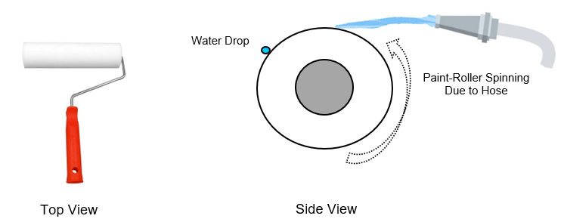

Answer ___________________ N

**Question 6 (6 marks)**

An exploratory space probe of mass 1720 kg is put into a low altitude orbit around the planet Mars, achieving a stable orbital velocity of 3.34 km s–1. Mars has a mass of 6.39 × 1023 kg and a radius of 3390 km.

(a) Calculate the altitude of the space probe, to the nearest km. (4 marks)

Answer ___________________ km

(b) Calculate the net acceleration experienced by the space probe. If you could not calculate part (a), you can use an altitude of 400 km. (2 marks)

Answer ___________________ m s–2

**Question 7 (5 marks)**

A simple generator is constructed from a single loop of wire HIJK as shown. The single loop of wire forms a rectangle with side IJ = 7.00 cm and side HI = 12.0 cm and sits between the poles of magnet P and magnet Q, in a magnetic field of strength 0.135 T. The loop of wire is rotated at a rate of 2.50 revolutions per second.

(a) At the instant shown, current flows anticlockwise from K to H and side KJ moves into the page while side IH moves out of the page. In the dotted boxes above, indicate the polarity (either north – N, or south – S) of the poles on magnets P and Q. (1 mark)

(b) Determine the peak voltage generated in the loop HIJK, expressing your answer in millivolts (mV). (2 marks)

Answer (peak) ________________ mV

(c) The dimensions of sides IJ and HI are each doubled. Describe one specific change that you could make to the design or operation of the generator to ensure that the peak voltage remains the same.

(2 marks)

**Question 8 (5 marks)**

A water drum is hanging in the corner of a shed using two strong but light ropes of negligible mass. Rope 1 makes a right angle with the wall while rope 2 makes an angle of with the roof.

(a) Which rope will experience the greatest tensile force? Circle your answer below. (1 mark)

Rope 1 Rope 2

(b) With reference to the principle of equilibrium and other relevant formula, explain your answer to part (a). Your explanation may include equations/calculations if desired. (4 marks)

________________________________________________________________________

________________________________________________________________________

________________________________________________________________________

________________________________________________________________________

________________________________________________________________________

________________________________________________________________________

________________________________________________________________________

________________________________________________________________________

________________________________________________________________________

________________________________________________________________________

________________________________________________________________________

________________________________________________________________________

________________________________________________________________________

**Question 9 (3 marks)**

Determine the force per metre due to the Earth’s magnetic field that acts on a high-power transmission line running in a NE direction at the equator. The transmission line is carrying a current of 1.25 × 103 A and the magnetic field strength at this location is 31.0 µT. You may assume that the magnetic field lines at the equator are parallel to the Earth’s surface.

Answer ________________ N m–1

**Question 10 (4 marks)**

A circular loop of wire of is placed at right angles to a uniform magnetic field as shown in the diagram. The magnetic field is then switched off over a short period of time.

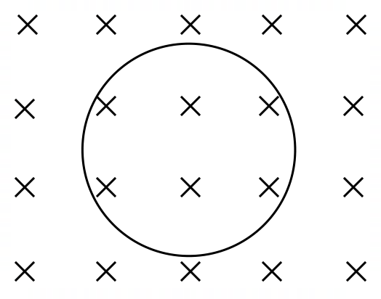

(a) In which direction will current flow in the loop in response to this change in flux? Circle your response below. (1 mark)

CLOCKWISE ANTICLOCKWISE

(b) Explain your answer to part (a) with reference to Lenz’s law. (3 marks)

________________________________________________________________________

________________________________________________________________________

________________________________________________________________________

________________________________________________________________________

________________________________________________________________________

________________________________________________________________________

________________________________________________________________________

**Question 11 (5 marks)**

A construction worker accidentally fires a nail gun from the top of a 26.0 m high building, releasing the nail horizontally at 34.0 m s–1. Ignoring air resistance, calculate the velocity of the nail just before it hits the ground 26.0 m below.

Answer __________________ m s–1 at an angle of _____________° to the ground.

**Section Two: Problem Solving 50% (90 marks)**

This section has **seven (7)** questions. Answer **all** questions. Write your answers in the space provided.

Suggested working time for this section is 90 minutes.

**Question 12 (15 marks)**

A linear induction torch (sometimes referred to as a Faraday’s Flashlight) is designed to be operated manually, not powered by batteries but by the simple shaking of the torch.

Position A

Position B

18 cm

2.5 cm

cylindrical neodymium magnet

LED light

capacitor and switch

coil of wire

When the torch is shaken lengthwise a cylindrical neodymium magnet slides through the middle of the coil, generating electric current, storing energy in the capacitor, providing energy for the LED. The torch is efficient enough to provide 2 to 3 minutes of light with about 10 seconds of shaking.

(a) With reference to Faraday’s law, explain how the capacitor in the torch is charged.

(4 marks)

________________________________________________________________________

________________________________________________________________________

________________________________________________________________________

________________________________________________________________________

________________________________________________________________________

________________________________________________________________________

________________________________________________________________________

________________________________________________________________________

The graph below shows the variation in flux density (in Tesla) in the coil as the magnet travels from position A to position B. A positive flux density refers to field lines passing from left to right through the coil of wire. You may assume the magnet moves at a constant speed between A and B.

(b) Using the diagram above, indicate the shape of the induced voltage in the coil over the given timeframe on the graph below. There is no need to indicate a vertical scale for the EMF.

(4 marks)

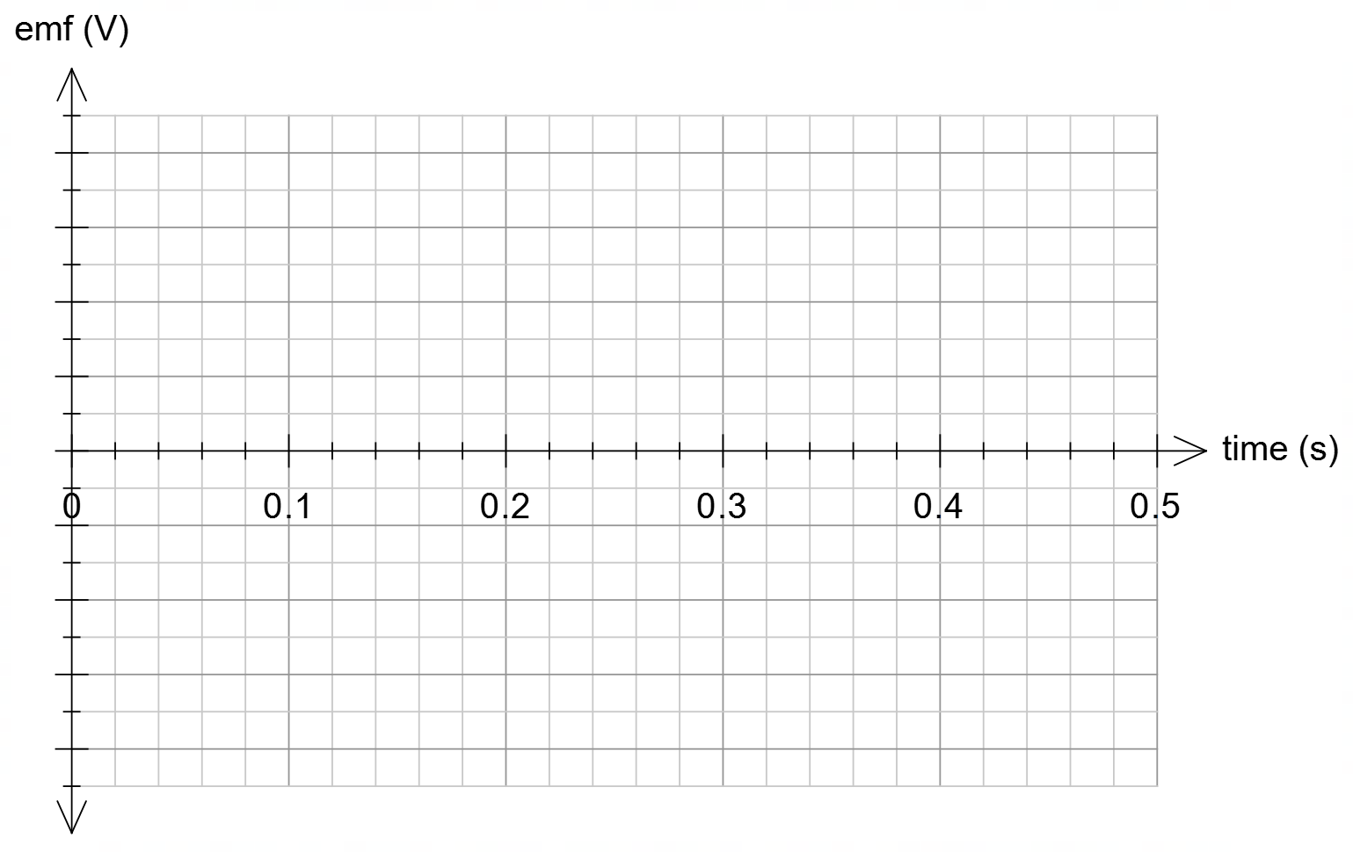

(c) Using Faraday’s Law for the induced voltage in the coil as well as Ohm’s law, show that the number of turns in the coil can be approximated by the following equation: (3 marks)

where is the induced current (A)

is the resistance of the coil wire (Ω)

is the time for the flux to change (seconds)

is the change in the field of the magnet (T)

is the cross-sectional area of the coil (m2)

(d) When the magnet slides through the coil, a peak current of 84.0 mA is generated. Given that the coil has a resistance 3.45 Ω, estimate the number of turns in the coil. It may be necessary to approximate certain values from the torch-diagram and flux-density graph to complete the equation. Answer to an appropriate number of significant figures. (4 marks)

Answer _________________

**Question 13 (10 marks)**

Overhead electricity for metropolitan railways in Perth use wires which are electrified at high voltages, carrying currents of 5.00 × 102 A. The electric wires are attached to a “registration arm” as shown below.

The “registration arm” is a solid structure consisting of a horizontal 1.70 m long arm PQ and a vertical arm QW. The “registration arm” is hinged at point P, has a mass of 2.68 kg and its centre of mass acts 1.40 m from point P as shown.

A cable, of negligible mass, supports the registration arm as shown, is attached to pole PQ at a position 1.25 m from point P, and makes an angle of 52.0° with the arm PQ as shown.

The electric wire hangs on the end of the “registration arm”, exerting a downward weight force of 19.0 N on the “registration arm”, directly below point Q.

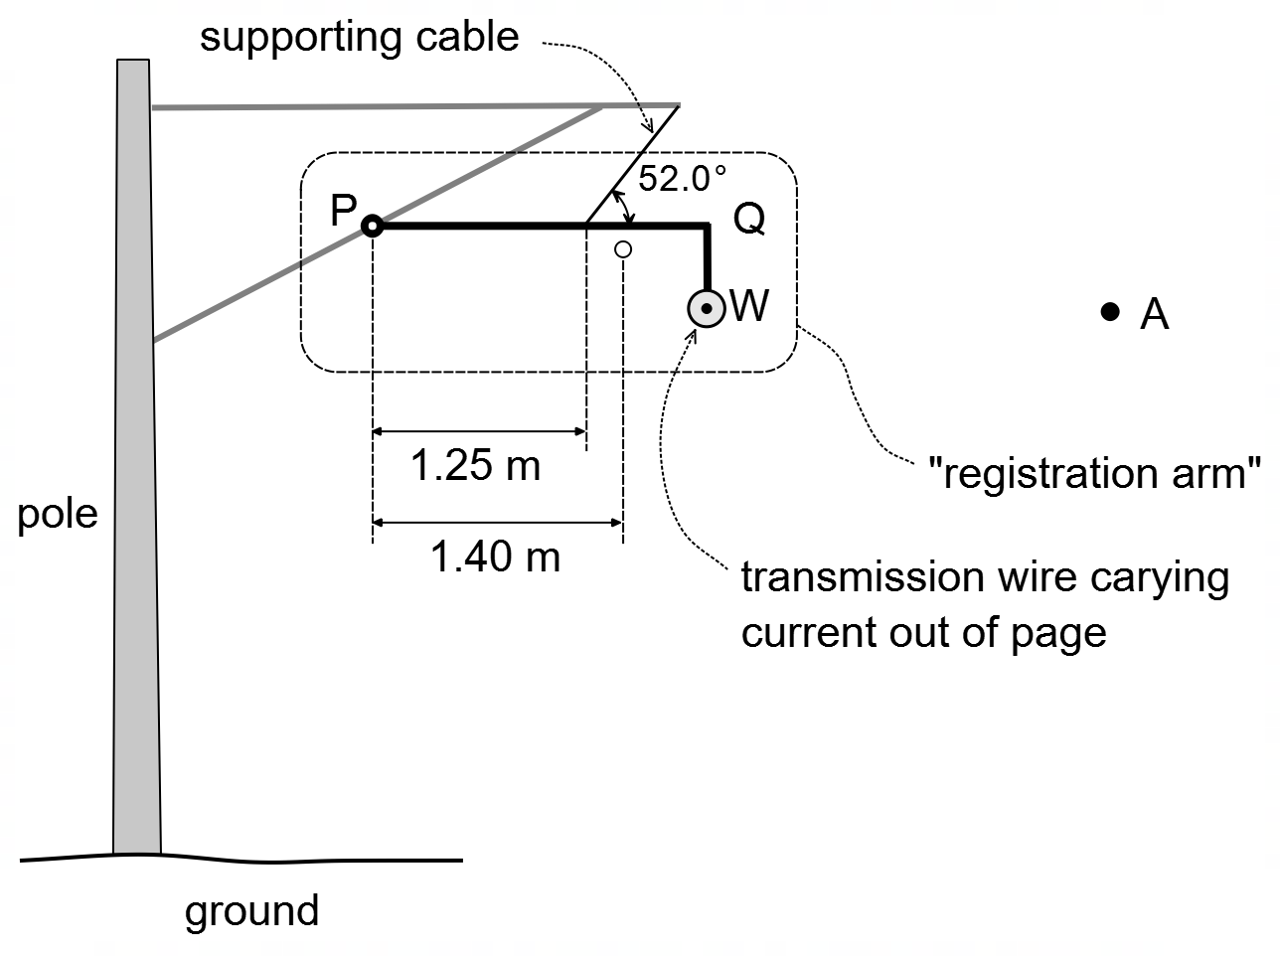

(a) Identify the direction of the magnetic field at point A due to the current in the transmission wire. Circle the correct answer below. (1 mark)

LEFT RIGHT UP DOWN INTO OUT

(b) Calculate the strength of the magnetic field 2.00 m from the wire. (3 marks)

Answer _________________ T

(c) Determine the sum of the clockwise torques acting about the hinge, point P. (3 marks)

Answer _________________ Nm

(d) Using your answer from part (c), determine the tension in the supporting cable. If you could not determine part (c), you may use a net clockwise torque of 70 Nm. (3 marks)

Answer ______________ N

**Question 14 (13 marks)**

A girl throws a table tennis ball vertically upwards at 5.00 m s–1 towards the ceiling, which is 1.00 m above the point of release. As the ball bounces off the ceiling, the ball bounces elastically such that the speed the ball hits the ceiling upwards is equal to the speed the ball leaves the ceiling downwards. The girl then catches the ball 50.0 cm *below* the point of release.

You may ignore air resistance in this question.

(a) Determine the speed at which the table tennis ball hits the ceiling. (3 marks)

Answer ________________ m s–1

(b) Calculate the time of flight of the table tennis ball, from release to catch. (5 marks)

Answer ________________ s

(c) Draw a velocity–time graph for the table tennis ball from the point of release to the point of catch. Indicate a suitable scale on both axes. You may assume that upwards is a positive velocity. (5 marks)

**Question 15 (14 marks)**

A ball of mass 1.50 kg is being swung in a horizontal circular path such that the 1.50 m long wire makes an angle of 50.0° with the vertical.

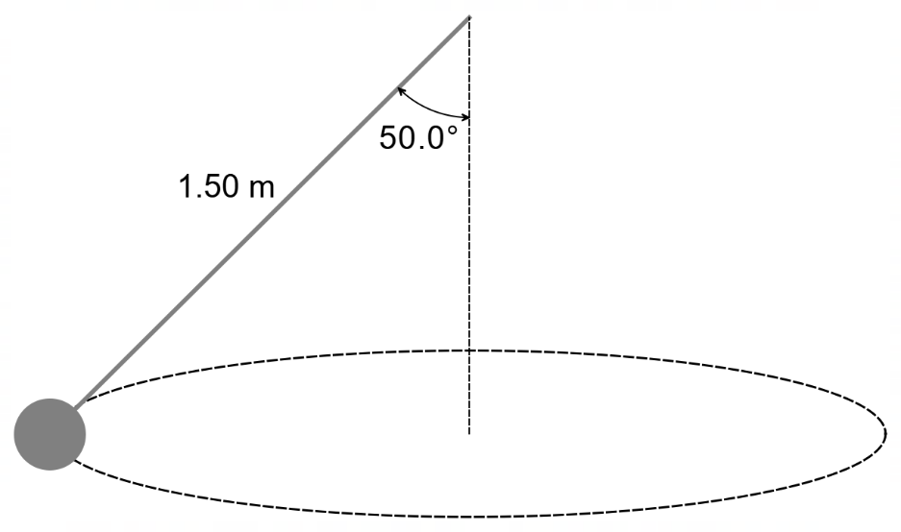

(a) In the space below, draw a vector diagram of the forces acting on the ball, indicating the net force and any relevant angles. (3 marks)

(b) Calculate the tension in the wire. (3 marks)

Answer ________________ N

(c) Calculate the speed of the ball. If you could not calculate part (b), you may use a tension force of 25 N. (5 marks)

Answer ________________ m s–1

(d) The speed of the ball is now doubled. Explain, with relevant physics, why the angle of the wire to the vertical increases as the speed of the ball doubles. (3 marks)

________________________________________________________________________

________________________________________________________________________

________________________________________________________________________

________________________________________________________________________

________________________________________________________________________

________________________________________________________________________

________________________________________________________________________

________________________________________________________________________

________________________________________________________________________

**Question 16 (11 marks)**

A simple DC motor is constructed by wrapping a length of wire into a 24.0 cm by 18.0 cm coil with 15 turns of wire. The coil is placed horizontally in a magnetic field of strength 0.316 T, between the poles of two permanent magnets, as shown.

(a) The coil starts from the position shown and a potential difference of 15.0 V is applied across the terminals of the coil, drawing a current of 5.00 A in the coil.

(i) In which direction will side CD move? Circle your answer. (1 mark)

INTO PAGE OUT OF PAGE

(ii) Determine the torque experienced by the coil at the position shown. (3 marks)

Answer _______________ Nm

(b) The motor is disassembled after use. In place of the armature, a soft-iron metal bar is placed in between the two magnets. Sketch below the resultant magnetic field (draw at least 4 field lines):

(3 marks)

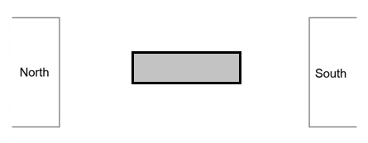

(c) The wire for the armature windings is recycled, and a single length of wire from the side AB is taken. In Perth, the magnetic field is strength of the Earth is approximately 5.85 x 10-5 T, angled at 66⁰ to the horizontal.

If the wire is held vertically, determine the horizontal speed at which this wire would need to move in order to induce a 5.00 x 10-4 V potential difference between the two ends, and state which end (top or bottom) would have a net positive charge.

(4 marks)

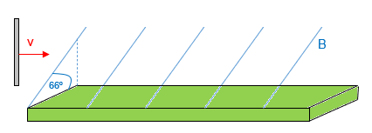

**Question 17 (14 marks)**

A circus performer is rotating an 8.50 × 102 g flaming torch on the end of a 1.20 m string. Once the torch is brought up to speed, it rotates freely under the influence of gravity in a vertical circular path of radius 1.20 m. The string can withstand a tensile force of 60.0 N before it snaps.

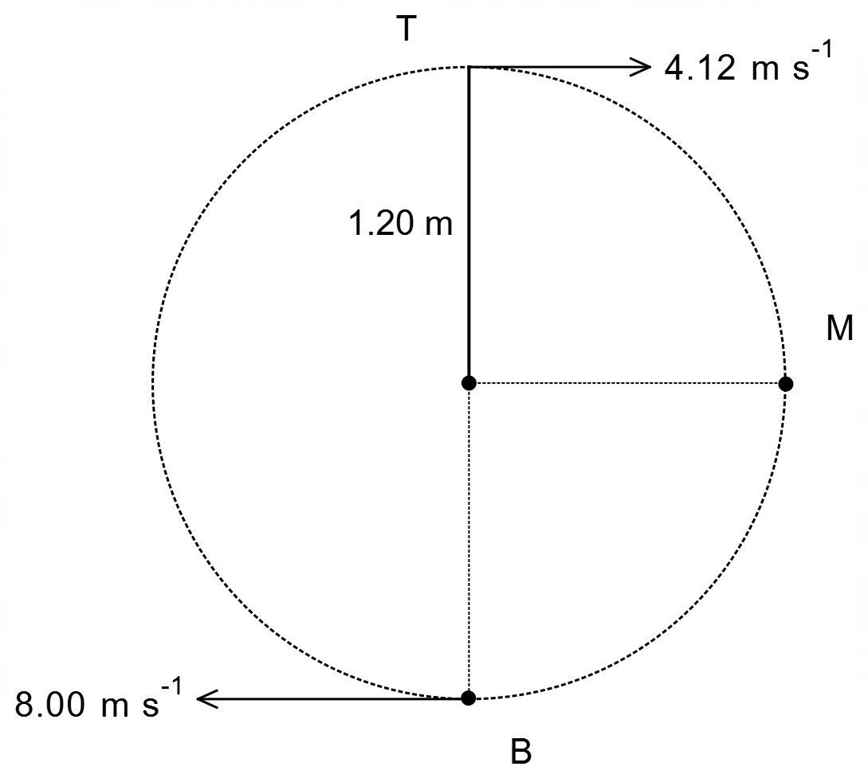

(a) Identify the position where the tension in the string will be greatest (top – point T, middle – point M or bottom – point B). Circle your answer below. (1 mark)

Point T Point M Point B

(b) With the use of a suitable calculation, show that the tension in the string never reduces to zero as the torch follows its circular path. (3 marks)

(c) Determine whether the string can withstand the forces it experiences as it undergoes the circular motion described. Justify your answer with a relevant calculation. (4 marks)

(d) Using an energy consideration, show that the centripetal acceleration of the flaming torch at point M is approximately 34 m s–2. (6 marks)

**Question 18 (13 marks)**

Eris is the second largest dwarf planet, orbiting the Sun far beyond Neptune, in a region known as the Kuiper Belt. Eris has one known moon called Dysnomia.

Some physical characteristics of the dwarf planet Eris and its moon Dysnomia are given below.

Mass of Eris 1.66 × 1022 kg Orbital radius of Eris 1.02 × 1010 km

Mean Eris – Dysnomia distance 3.73 × 104 km

(a) Using the information given and data from your Formula and Data Booklet, show that the orbital period of Eris is approximately 560 Earth years. (5 marks)

(b) Calculate the orbital speed of the moon Dysnomia about Eris. (3 marks)

Answer ________________ m s–1

(c) The mass of the moon Dysnomia is difficult to calculate, given it is not known whether it is a solid object or not. However, it has been estimated that it could be between 37 and 115 times smaller than the mass of Eris. Using calculations, express the mass of Dysnomia with an associated uncertainty. Give your answers to an appropriate number of significant figures. (5 marks)

Answer ___________________ ± ____________________ kg

**This page has been left blank intentionally**

**Section Three: Comprehension 20% (36 marks)**

This section has two (2) questions. Answer **both** questions in the spaces provided.

Suggested working time: 40 minutes.

**Question 19 (18 marks)**

**The Hall Effect**

In 1879 Edwin Hall discovered that a current passing through a conductor, held within a magnetic field, will establish a small transverse voltage across the width of the conductor. This effect is known as the Hall Effect and is most evident in a thin flat conductor as shown below.

The Hall Effect can be used to detect the presence of small magnetic fields surrounding metallic conductors as well as detect currents in nearby conductors.

In the diagram below the conductor is positioned within a magnetic field. When charge carriers pass through the conductor, at right angles to the magnetic field, the magnetic field exerts a force on the moving charge carriers. This magnetic force pushes the charge carriers to one side of the conductor, establishing a small, but detectable voltage across the width of the conductor.

As a result of the charge carriers travelling closer to one side of the conductor than to the other, one side of the conductor will have a net negative charge and a net positive charge on the other. This charge separation sets up an electric field across the width of the conductor, exerting an electric force on the charge carriers. This electric force acts in the opposite direction to the magnetic force.

As the charge separation increases, the electric field builds up until the electric force on each moving charge carrier is equal and opposite to the force due to the magnetic field. At this point, the small detectable voltage difference is known as the “Hall Voltage”.

The velocity of the electron flow through the material is known as the “drift velocity” .

The drift velocity is given by the following equation:

Where is the speed of the electrons through the material (m s–1)

is the current flowing in the conductor (A)

is the density of charge carriers within the material (m-3)

is the magnitude of the charge on an electron (C)

is the cross-sectional area of the conductor ( (m2)

To test the Hall Effect, a group of students used a piece of copper metal with cross-sectional dimensions 30.0 mm and 4.00 mm. The students placed the copper metal horizontally in a vertical magnetic field of strength 2.76 T. The students varied the current through the conductor and measured the Hall Voltage across the conductor, tabulating their results below.

|  |  |
| --- | --- |
| Current (A) | Hall Voltage (×10–6 V) |
| 35.9 | 1.80 |
| 56.3 | 2.85 |
| 73.1 | 3.71 |
| 81.0 | 4.12 |
| 95.1 | 4.85 |
| 106 | 5.38 |

(a) Assuming the magnetic and electric forces on passing electrons are in equilibrium, as shown in the diagram, show that the Hall Voltage () is given by the following equation. You can use Equation 1 and relevant formulae from your Formula and Data Booklet. (4 marks)

(b) On the graph on the next page construct a graph of Hall Voltage (V) on the vertical axis versus current (A) on the horizontal axis. Indicate an appropriate scale and draw in a line of best fit through the data. (4 marks)

(c) Calculate the gradient of the line of best fit. Indicate construction lines and coordinates of the points used. Include units in your answer. (4 marks)

Answer _______________ units ___________

(d) Use your gradient of your line of best fit to determine the charge carrier density of the copper metal used in this experiment. Give your answer to an appropriate number of significant figures. If you could not calculate the gradient of your line of best fit, you may use a gradient of 5.0 × 10–8. (4 marks)

Answer ___________________ m–3

(e) Explain how a device using the Hall Effect could be used to detect a current in a nearby conductor. (2 marks)

________________________________________________________________________

________________________________________________________________________

________________________________________________________________________

________________________________________________________________________

**Question 20 (18 marks)**

**Gravitational Potential Energy & Escape Velocity**

**Gravitational Potential Energy**

All objects experience a force when they are in a gravitational field. Therefore, all objects in a gravitational field possess gravitational potential energy (GPE). Gravitational potential energy (J) is defined as the energy an object of mass (kg) possesses because of its position (m) within a gravitational field (m s–2) and is given as:

The work done (J) on an object in a gravitational field is simply the change in the gravitational potential energy of the object:

where positive is the work done by or on the object in a gravitational field. This assumes some arbitrary reference point . On Earth, we normally set the surface of the earth (or sea level) as this reference point.

When considering larger distances (i.e., orbits and beyond), this treatment of GPE becomes problematic. It is well known that the acceleration due to gravity is not constant, but also varies with distance from the centre of gravitation. Using Newton’s Law of Universal Gravitation, g is given by:

When factoring in the decreasing gravitational acceleration as distance increases, you would expect that there would be a point in space () where there is no gravitational influence and thus no potential energy (). It makes more sense to use this as our reference point instead of the Earth’s surface. To ensure that the GPE decreases as you get closer to Earth, GPE should be negative given by the following equation:

Where is the Newtonian constant of gravitation

is the mass of the attracting body (kg)

is the mass of the smaller body (kg)

is the distance between their centres (m)

According to Equation 4, in this reference system, the gravitational potential energy is always negative. This ensures that the gravitational potential energy increases with increased distance, as one would expect.

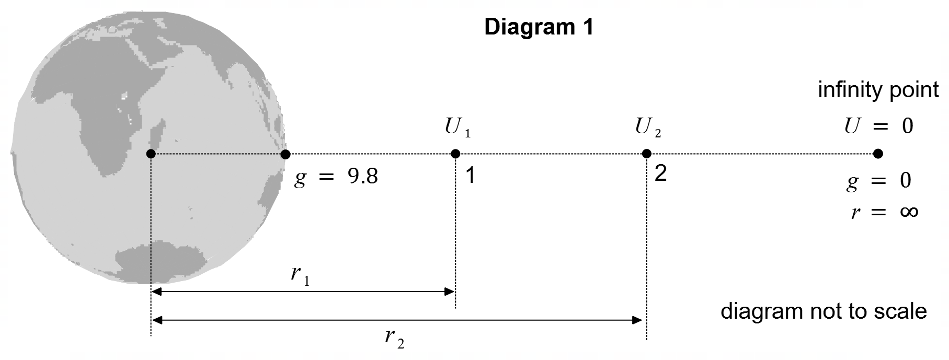

**Escape Velocity**

The total energy of an object is equal to the sum of its kinetic energy and its gravitational potential energy according to:

For an object to escape the force of gravity of another larger object, we need to consider what happens at the “infinity point”. As the object travels further from the centre of gravitation, its kinetic energy is converted to potential energy. As the object approaches , both its kinetic and potential energies approach zero.

From an energy perspective, for an object to escape the gravity of a larger body, it must possess enough kinetic energy to be converted to potential energy, bringing to zero, meaning that the object is no longer under the influence of gravity. In other words, .

Thus, it can be shown that the escape velocity (m s–1) is given by:

where is the Newtonian constant of gravitation, (kg) is the mass of the attracting body and the radius (m) is the distance of the object from the centre of the attracting body.

Diagram 2, below, shows the variation of the kinetic energy of an object as it escapes the gravity of an attracting body. The horizontal scale on the graph is in terms of the radius of the attracting body (i.e., represents the surface radius of the attracting body).

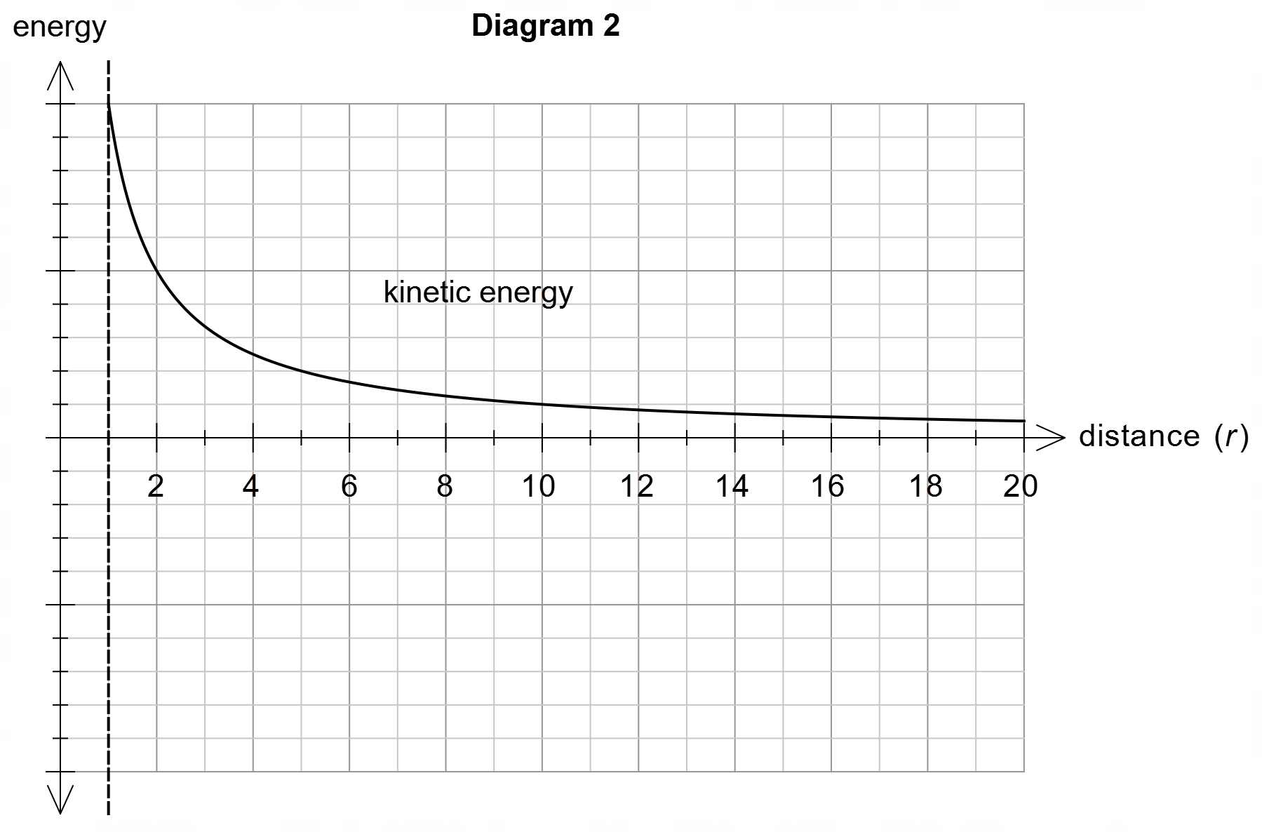

(a) State two reasons why the assumption that the gravitational potential energy of an object anywhere as given by Equation 1, is invalid. (2 marks)

Reason 1 _______________________________________________________________

_______________________________________________________________

Reason 2 _______________________________________________________________

_______________________________________________________________

(b) Diagram 1 shows an object at two positions (1 and 2). By using Equation 4, show that the change in the gravitational potential energy of this object, as it moves from position 1 to position 2, is a positive value. (3 marks)

(c) On Diagram 2, draw the gravitational potential energy curve for the object that escapes the gravity of an attracting body. (2 marks)

(d) Calculate the escape velocity of a rocket from the surface of the Earth. (3 marks)

Answer ________________ km s–1

(e) Would the escape velocity from the surface of the Moon be greater or smaller than the escape velocity from the surface of the Earth? Justify your response using relevant information from the text and data from your Formula and Data Booklet. No calculations are necessary. (4 marks)

(f) The Voyager 1 space probe is in space beyond the solar system at a distance from the Earth of 158 AU (1 AU = 1.50 × 1011 m). At this distance, the 722 kg space probe can only gain about 12 kJ more potential energy due to the Earth’s gravitational field. Verify this energy estimate with an appropriate calculation. (4 marks)

Answer ________________ J

**End of Questions**

**Spare Graphs for Question 12 (b), 14 (c) and 19 (b)**

**Question 12 (b)**



**Question 14 (c)**

**Question 19 (b)**

**Additional working space**

Question number(s): ……………………

**ACKNOWLEDGEMENTS**

**Question 14** Image for Question 14:

Wikipedia contributors. (2022, May 17). Mechanically powered flashlight. In Wikipedia, The Free Encyclopedia. Retrieved 08:43, October 5, 2022, from https://en.wikipedia.org/w/index.php?title=Mechanically_powered_flashlight&oldid=1088386109

**Question 18** Information for Question 18:

Wikipedia contributors. (2022, October 2). Dysnomia (moon). In Wikipedia, The Free Encyclopedia. Retrieved 04:50, October 6, 2022, from https://en.wikipedia.org/w/index.php?title=Dysnomia_(moon)&oldid=1113659674

WATP acknowledges the permission of the School Curriculum and Assessment Authority in providing instructions to students.